Traversing Elements

**Get the parent element**

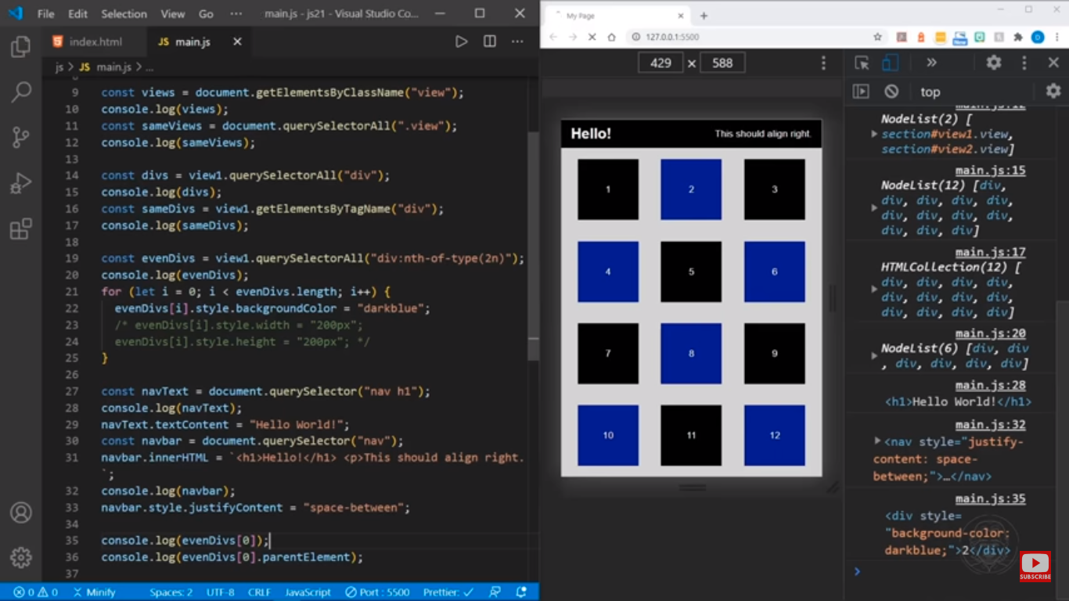

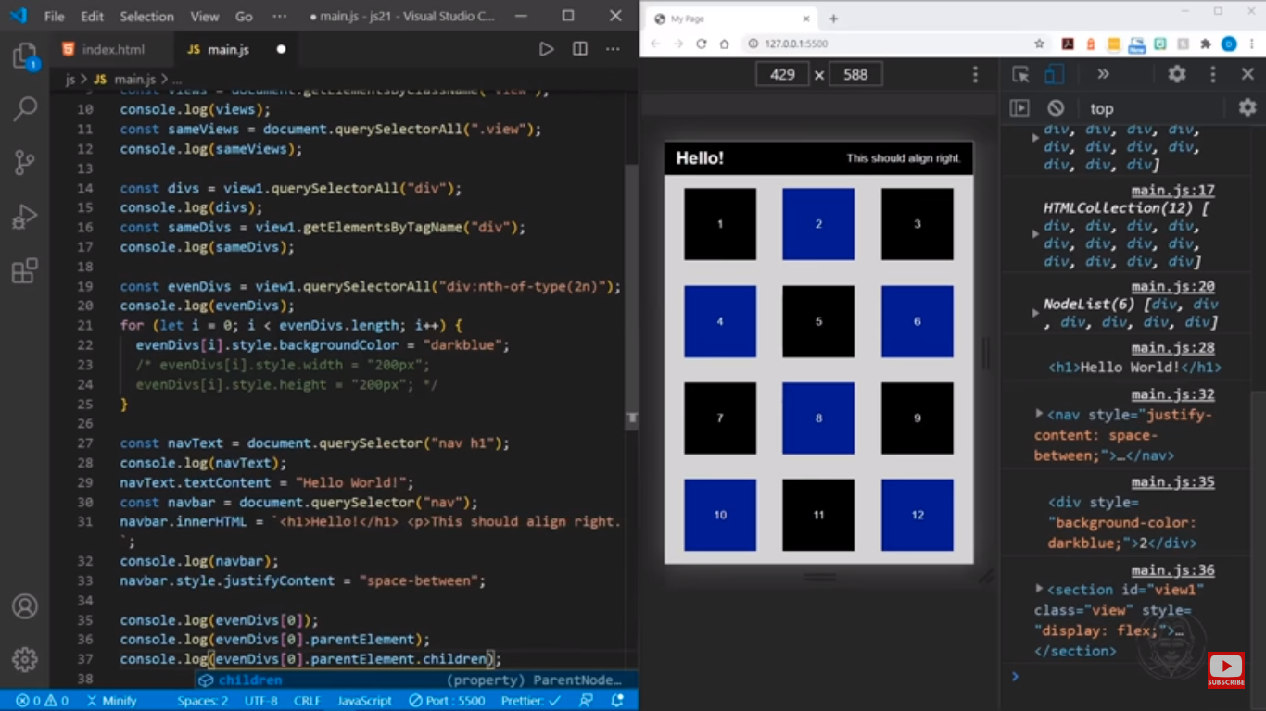

Introduction to parentNode attribute

To get the parent node of a specified node in the DOM tree, you use the parentNode property:

let parent = node.parentNode;Code language: JavaScript (javascript)

The parentNode is read-only.

The Document and DocumentFragment nodes do not have a parent. Therefore, the parentNode will always be null.

If you create a new node but haven’t attached it to the DOM tree, the parentNode of that node will also be null.

JavaScript parentNode example

See the following HTML document:

<!DOCTYPE html>

**<html>**

**<head>**

**<meta charset="utf-8">**

**<title>**JavaScript parentNode**</title>**

**</head>**

**<body>**

**<div id="main">**

**<p class="note">**This is a note!**</p>**

**</div>**

**<script>**

let note = document.querySelector('.note');

console.log(note.parentNode);

**</script>**

**</body>**

**</html>**

Code language: HTML, XML (xml)

The following picture shows the output in the Console:

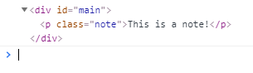

**Getting Child Elements of a Node in JavaScript**

Suppose that you have the following HTML fragment:

<!DOCTYPE html>

**<html>**

**<head>**

**<meta charset="utf-8">**

**<title>**JS Get Child Elements**</title>**

**</head>**

**<body>**

**<ul id="menu">**

**<li class="first">**Home**</li>**

**<li>**Products**</li>**

**<li class="current">**Customer Support**</li>**

**<li>**Careers**</li>**

**<li>**Investors**</li>**

**<li>**News**</li>**

**<li class="last">**About Us**</li>**

**</ul>**

**</body>**

**</html>**Code language: HTML, XML (xml)

## Get the first child element

To get the first child element of a specified element, you use the firstChild property of the element:

let firstChild = parentElement.firstChild;

Code language: JavaScript (javascript)

If the parentElement does not have any child element, the firstChild returns null. The firstChild property returns a child node which can be any node type such as an element node, a text node, or a comment node. The following script shows the first child of the #menu element:

let content = document.getElementById('menu');

let firstChild = content.firstChild.nodeName;

console.log(firstChild);Code language: JavaScript (javascript)

Output:

#textCode language: CSS (css)

The Console window show #text because a text node is inserted to maintain the whitespace between the openning <ul> and <li> tags. This whitespace creates a #text node.

Note that any whitespace such as a single space, multiple spaces, returns, and tabs will create a #text node. To remove the #text node, you can remove the whitespaces as follows:

**<article id="content"><h2>**Heading**</h2><p>**First paragraph**</p></article>**Code language: HTML, XML (xml)

Or to get the first child with the Element node only, you can use the firstElementChild property:

let firstElementChild = parentElement.firstElementChild;Code language: JavaScript (javascript)

The following code returns the first list item which is the first child element of the menu:

let content = document.getElementById('menu');

console.log(content.firstElementChild);Code language: JavaScript (javascript)

Output:

**<li class="first">**Home**</li>**Code language: HTML, XML (xml)

In this example:

* First, select the #menu element by using the [getElementById()](https://www.javascripttutorial.net/javascript-dom/javascript-getelementbyid/) method.
* Second,  get the first child element by using the firstElementChild property.

## Get the last child element

To get the last child element of a node, you use the lastChild property:

let lastChild = parentElement.lastChild;

Code language: JavaScript (javascript)

In case the parentElement does not have any child element, the lastChild returns null. Similar to the the firstChild property, the lastChild property returns the first element node, text node, or comment node. If you want to select only the last child element with the element node type, you use the lastElementChild property:

let lastChild = parentElement.lastElementChild;Code language: JavaScript (javascript)

The following code returns the list item which is the last child element of the menu:

let menu = document.getElementById('menu');

console.log(main.lastElementChild);

Code language: JavaScript (javascript)

Output:

**<li class="last">**About Us**</li>**Code language: HTML, XML (xml)

## Get all child elements

To get a live NodeList of child elements of a specified element, you use the childNodes property:

let children = parentElement.childNodes;

Code language: JavaScript (javascript)

The childNodes property returns all child elements with any node type. To get the child element with only the element node type, you use the children property:

let children = parentElement.children;Code language: JavaScript (javascript)

The following example selects all child elements of the element with the Id main:

let menu = document.getElementById('menu');

let children = menu.children;

console.log(children);Code language: JavaScript (javascript)

Output:

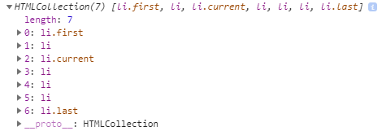

**Siblings**

Let’s say you have the following list of items:

**<ul id="menu">**

**<li>**Home**</li>**

**<li>**Products**</li>**

**<li class="current">**Customer Support**</li>**

**<li>**Careers**</li>**

**<li>**Investors**</li>**

**<li>**News**</li>**

**<li>**About Us**</li>**

**</ul>**

Code language: HTML, XML (xml)

## Get the next siblings

To get the next sibling of an element, you use the nextElementSibling attribute:

let nextSibling = currentNode.nextElementSibling;Code language: JavaScript (javascript)

The nextElementSibling returns null if the specified element is the last one in the list.

The following example uses the nextElementSibling property to get the next sibling of the list item that has the current class:

let current = document.querySelector('.current');

let nextSibling = current.nextElementSibling;

console.log(nextSibling);Code language: JavaScript (javascript)

Output:

**<li>**Careers**</li>**

Code language: HTML, XML (xml)

In this example:

* First, select the list item whose class is current using the [querySelector()](https://www.javascripttutorial.net/javascript-dom/javascript-siblings/).
* Second, get the next sibling of that list item using the nextElementSibling property.

To get all the next siblings of an element, you can use the following code:

let current = document.querySelector('.current');

let nextSibling = current.nextElementSibling;

while(nextSibling) {

console.log(nextSibling);

nextSibling = nextSibling.nextElementSibling;

}Code language: JavaScript (javascript)

## Get the previous siblings

To get the previous siblings of an element, you use the previousElementSibling attribute:

let current = document.querySelector('.current');

let prevSibling = currentNode.previousElementSibling;Code language: JavaScript (javascript)

The previousElementSibling property returns null if the current element is the first one in the list.

The following example uses the previousElementSibling property to get the previous siblings of the list item that has the current class:

let current = document.querySelector('.current');

let prevSiblings = current.previousElementSibling;

console.log(prevSiblings);Code language: JavaScript (javascript)

And the following example selects all the previous siblings of the list item that has the current class:

let current = document.querySelector('.current');

let prevSibling = current.previousElementSibling;

while(prevSibling) {

console.log(prevSibling);

prevSibling = current.previousElementSibling;

}

Code language: JavaScript (javascript)

## Get all siblings of an element

To get all siblings of an element, we’ll use the logic:

* First, select the parent of the element whose siblings you want to find.
* Second, select the first child element of that parent element.
* Third, add the first element to an array of siblings.
* Fourth, select the next sibling of the first element.
* Finally, repeat the 3rd and 4th steps until there are no siblings left. In case the sibling is the original element, skip the 3rd step.

The following function illustrates the steps:

let getSiblings = function (e) {

*// for collecting siblings*

let siblings = [];

*// if no parent, return no sibling*

if(!e.parentNode) {

return siblings;

}

*// first child of the parent node*

let sibling = e.parentNode.firstChild;

*// collecting siblings*

while (sibling) {

if (sibling.nodeType === 1 && sibling !== e) {

siblings.push(sibling);

}

sibling = sibling.nextSibling;

}

return siblings;

};

Code language: JavaScript (javascript)

Put it all together:

<!DOCTYPE html>

**<html>**

**<head>**

**<meta charset="utf-8">**

**<title>**JavaScript Siblings**</title>**

**</head>**

**<body>**

**<ul id="menu">**

**<li>**Home**</li>**

**<li>**Products**</li>**

**<li class="current">**Customer Support**</li>**

**<li>**Careers**</li>**

**<li>**Investors**</li>**

**<li>**News**</li>**

**<li>**About Us**</li>**

**</ul>**

**<script>**

let getSiblings = function (e) {

*// for collecting siblings*

let siblings = [];

*// if no parent, return no sibling*

if(!e.parentNode) {

return siblings;

}

*// first child of the parent node*

let sibling = e.parentNode.firstChild;

*// collecting siblings*

while (sibling) {

if (sibling.nodeType === 1 && sibling !== e) {

siblings.push(sibling);

}

sibling = sibling.nextSibling;

}

return siblings;

};

let siblings = getSiblings(document.querySelector('.current'));

siblingText = siblings.map(e => e.innerHTML);

console.log(siblingText);

**</script>**

**</body>**

**</html>**

Code language: HTML, XML (xml)

Output:

["Home", "Products", "Careers", "Investors", "News", "About Us"]

Examples

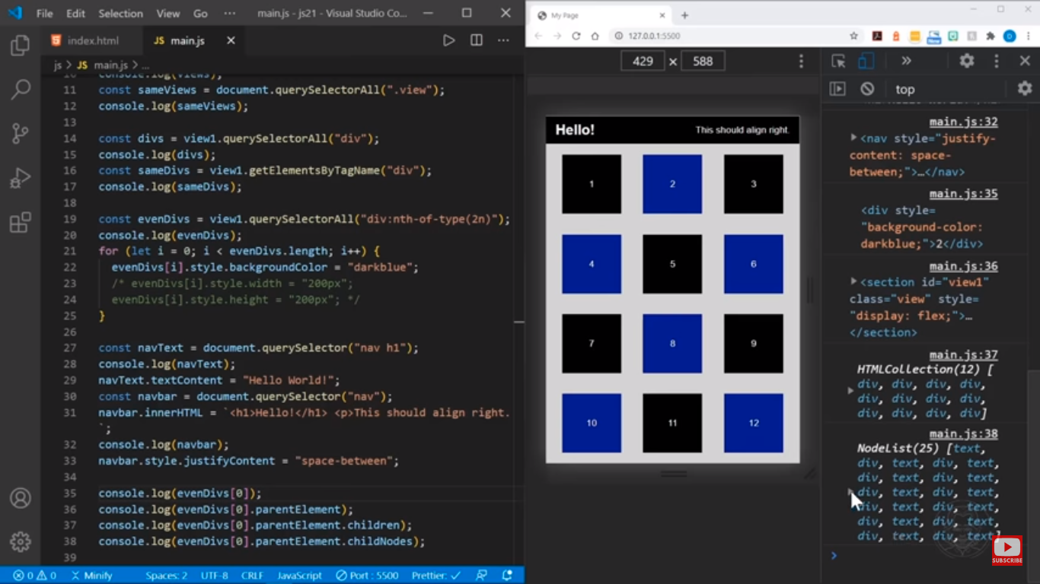

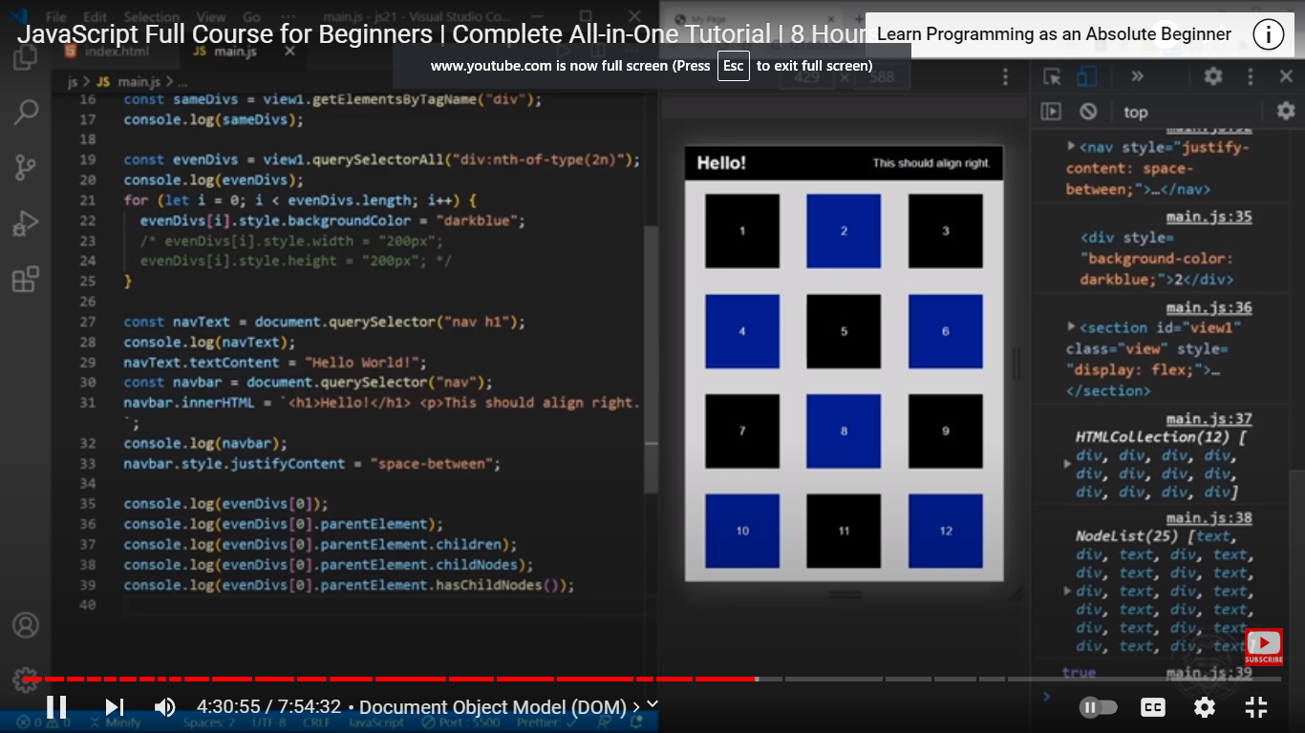

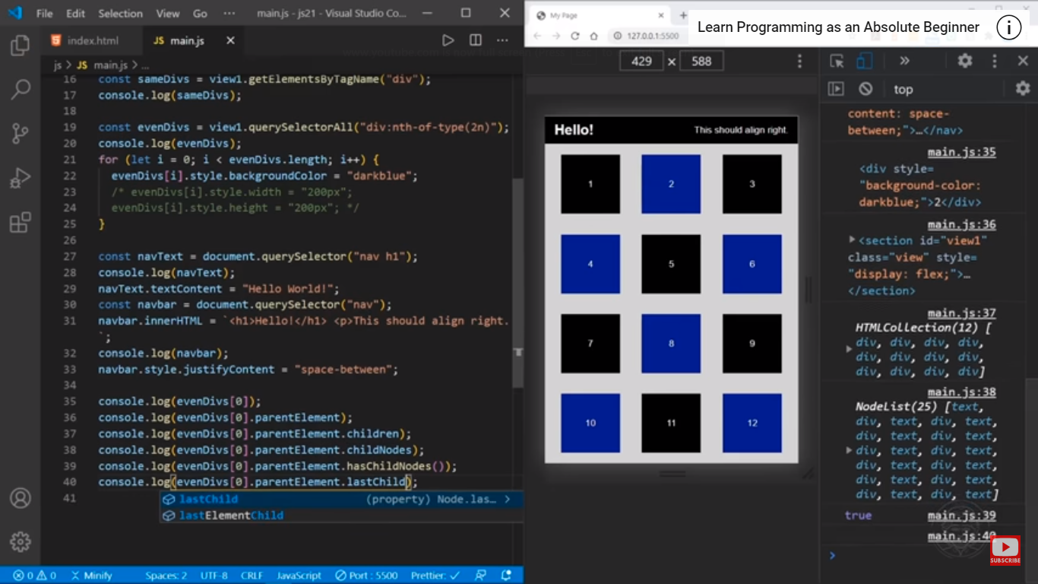

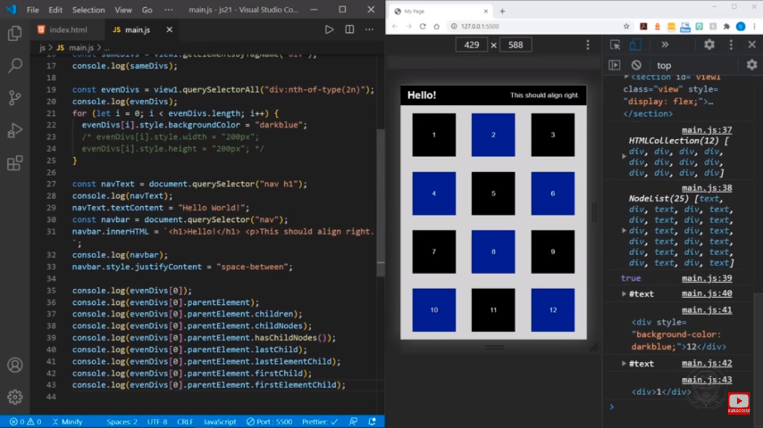

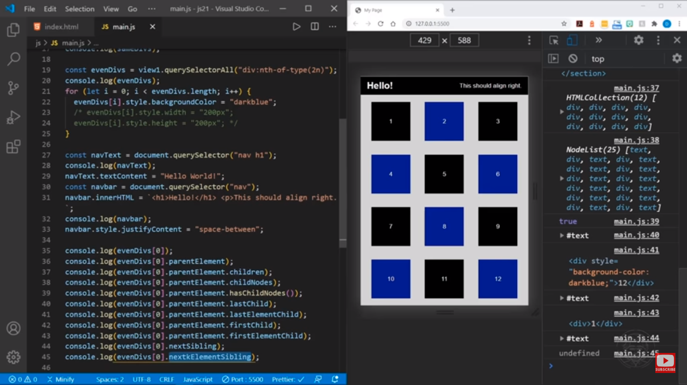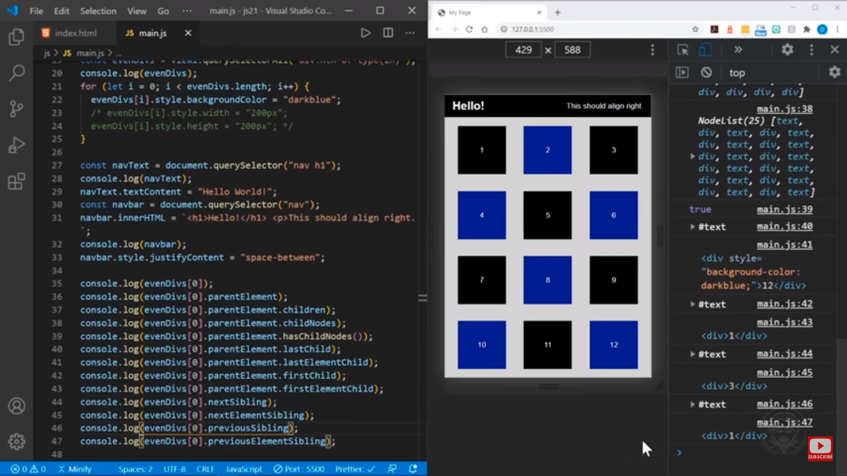

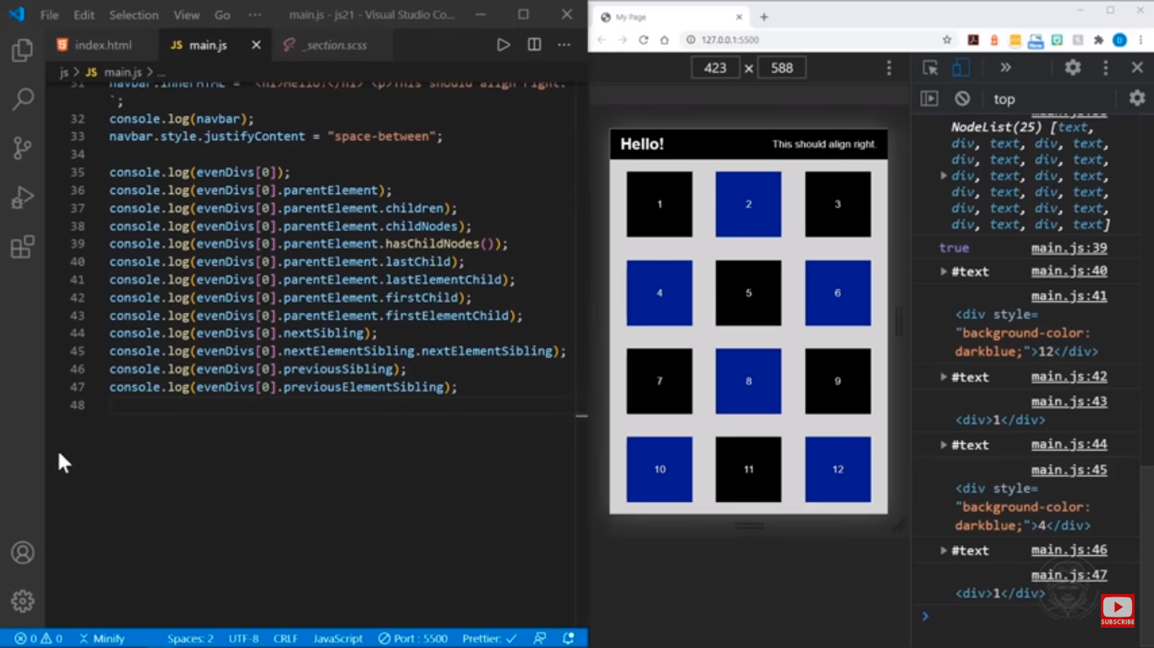

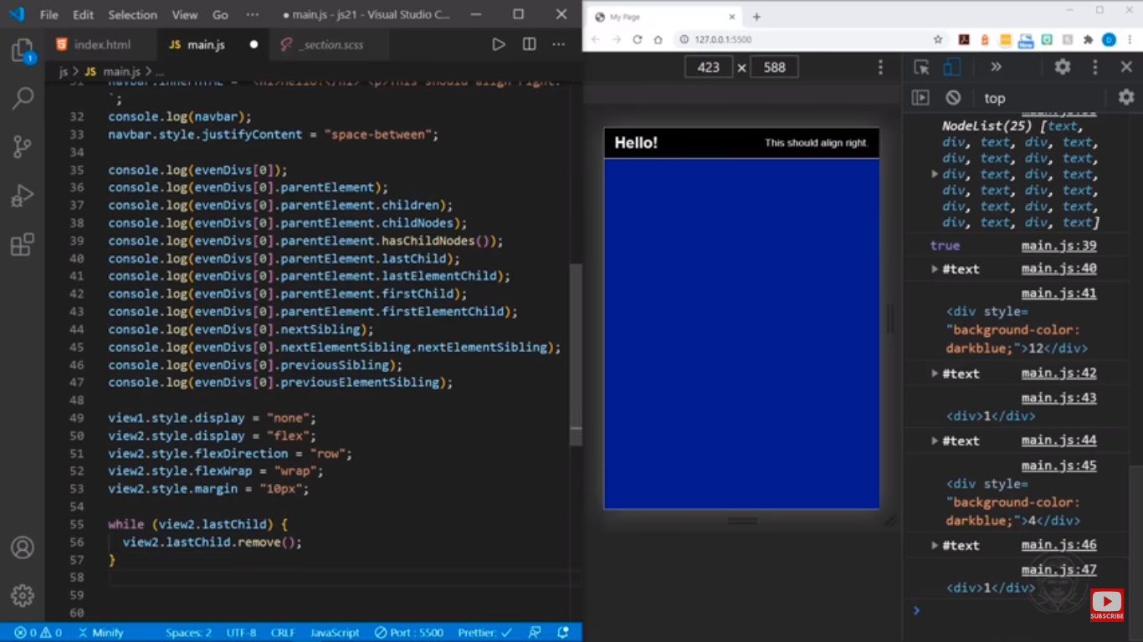

Imp

